Trauma, Posttraumatic Growth, and World Literature
Metamorphoses and a Literary Arts Praxis

Suzanne LaLonde

Routledge Publishing
Forthcoming May 2022

Monograph in the Literary Criticism and Cultural Theory Series

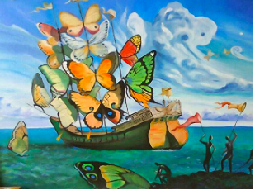
Pandemics, global climate chaos, worldwide migration crises? These phenomena are provoking traumatic experiences in unprecedented ways and numbers. This book is targeted for clinicians, scientists, cultural theorists, and other scholars and students of trauma studies interested in cultivating interdisciplinary understandings of trauma and posttraumatic conditions, especially resistance, resilience, and posttraumatic growth. Following clinicians’ invitation for trauma survivors to wear a philosopher’s hat, to engage in creative activities, and to employ cognitive exercises to combat psychic constriction, I introduce the concept of a Literary Arts Praxis. The Praxis is built on clinical research and literature seeped in existential, phenomenological, and aesthetic themes. I argue that an educational training in a Praxis might help trauma survivors to get at trauma, as they engage in imaginative escapades, while forging alliances with characters; interpretative exercises, such as triggering emotions through phenomenological experiences; and creative writing endeavors, that include turning testimonies into imaginative stories.

